Project Design Phase-II
Data Flow Diagram & User Stories

Date | Team ID | Project Name | Maximum Marks
13 July 2026 |  | SB Stocks | 4 Marks

Data Flow Diagrams
A Data Flow Diagram (DFD) is a graphical representation that illustrates how data moves through a system. It shows how information enters and exits, where it is stored, and how it is processed. For SB Stocks, the DFDs visualize the flow of data between users, the trading system, and external stock market data sources.

DFD Level 0 (Context Diagram) Description:
This diagram represents the SB Stocks system as a single process interacting with external entities such as the Trader (Web/Mobile) and External Stock Market API. It shows the overall data exchange without internal details.

Entities & Data Flow:

- Trader (Web/Mobile): Sends registration, login, and trading requests; receives confirmations, portfolio updates, and analytics.
- SB Stocks System: Central process handling all user requests and data management.
- External Stock Market API: Provides real-time and historical stock data to the system.

[DFD Level 0 (Context Diagram) Placeholder]

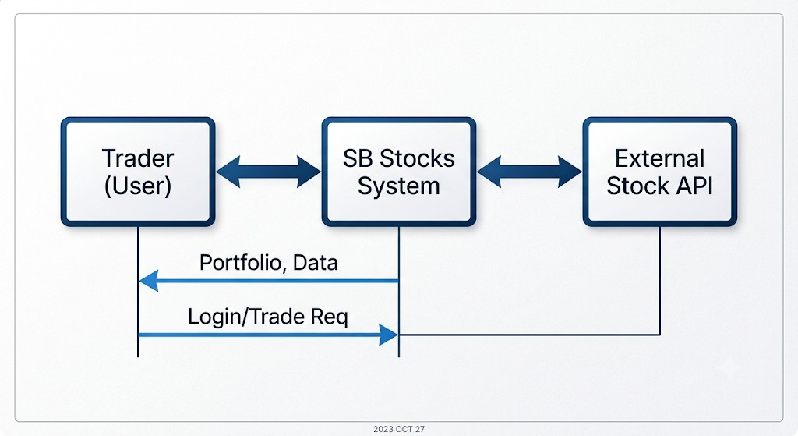

DFD Level 1 (Detailed Process Diagram) Description:
This diagram breaks down the SB Stocks System into key internal processes and data stores. It shows how user actions are processed and how data flows between modules.

Processes:

- User Management: Handles registration, login, and account updates.
- Trading Engine: Executes simulated buy/sell orders and updates portfolios.
- Market Data Processor: Fetches and updates real-time and historical stock data.
- Portfolio Manager: Tracks user holdings, profits/losses, and performance.
- Analytics & Reports: Generates insights and trading performance summaries.

Data Stores:

  - User Database (stores user credentials and profiles)
  - Portfolio Database (stores holdings and transaction history)
  - Market Data Repository (stores stock data and trends)

[DFD Level 1 (Detailed Process Diagram) Placeholder]

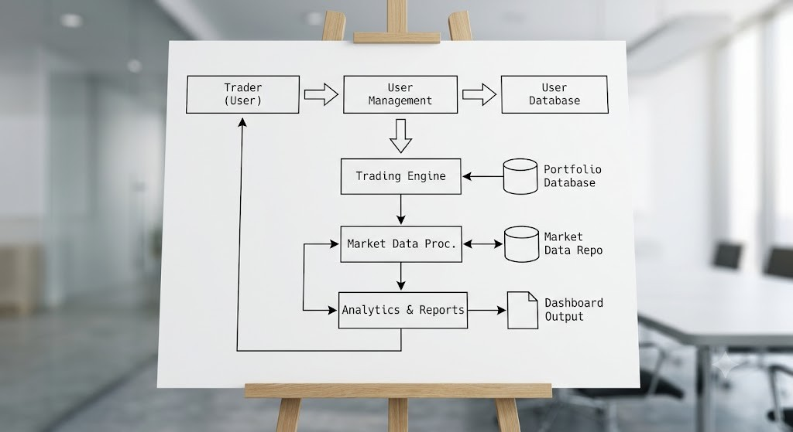

Complete Trading Workflow Diagram Description:
This diagram illustrates the end-to-end trading process — from user login to trade execution and performance tracking.

Workflow Steps:

- User logs in to the platform.
- System retrieves user portfolio and market data.
- User searches for a stock and places a buy/sell order.
- Trading engine simulates the transaction.
- Portfolio and transaction history are updated.
- Analytics module calculates performance metrics.
- User views updated dashboard and insights.

[Complete Trading Workflow Diagram Placeholder]

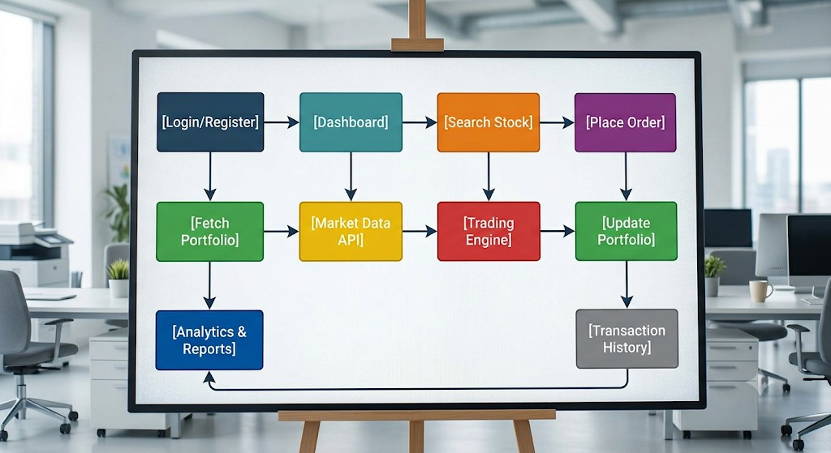

User Stories
The following table lists all user stories for the SB Stocks paper trading platform. Each story defines a specific functionality, acceptance criteria, priority, and release plan.

User Type | Functional Requirement  (Epic) | User Story Number | User Story / Task | Acceptance Criteria | Priority | Release
Trader (Web user) | Registration | USN-1 | As a trader, I can register using my email and  password. | Account created successfully. | High | Sprint-1
Trader (Web user) | Registration | USN-2 | As a trader, I receive a confirmation email  after registration. | Confirmation email received. | High | Sprint-1
Trader (Mobile user) | Registration | USN-3 | As a mobile trader,  I can register using Google account. | Successful Google  login and registration. | Medium | Sprint-2
Trader (Mobile user) | Registration | USN-4 | As a mobile trader,  I can register using Apple ID. | Successful Apple ID registration. | Low | Sprint-3
Trader (Web user) | Login | USN-5 | As a trader, I can log in using my credentials. | Successful login and dashboard access. | High | Sprint-1
Trader (Mobile user) | Login | USN-6 | As a mobile trader, I can stay logged in using  “Remember Me”. | Session persists after app restart. | Medium | Sprint-2
Trader (Web user) | Dashboard | USN-7 | As a trader, I can view my portfolio summary on the  dashboard. | Portfolio data displayed correctly. | High | Sprint-1
Trader (Web user) | Dashboard | USN-8 | As a trader, I can view real-time  stock prices on the  dashboard. | Live data updates every few seconds. | High | Sprint-1
Trader (Web user) | Paper Trading | USN-9 | As a trader, I can place a simulated buy order. | Order processed and reflected in portfolio. | High | Sprint-1
Trader (Web user) | Paper Trading | USN-10 | As a trader, I can place a simulated sell order. | Order processed and reflected in portfolio. | High | Sprint-1
Trader (Web user) | Portfolio Management | USN-11 | As a trader, I can view my holdings and unrealized  gains/losses. | Portfolio values calculated accurately. | High | Sprint-2

Trader (Web user) | Portfolio Management | USN-12 | As a trader, I can  reset my portfolio to start fresh. | Portfolio reset  confirmation displayed. | Medium | Sprint-3
Trader (Web user) | Stock Market Data | USN-13 | As a trader, I can view real-time  stock data from US  markets. | Data fetched from external API. | High | Sprint-1
Trader (Web user) | Stock Market Data | USN-14 | As a trader, I can  view historical price charts. | Chart displays  accurate historical data. | Medium | Sprint-2
Trader (Web user) | Search & Filter | USN-15 | As a trader, I can search for stocks by name or  symbol. | Search results displayed instantly. | High | Sprint-1
Trader (Web user) | Search & Filter | USN-16 | As a trader, I can filter stocks by sector or price  range. | Filtered results displayed correctly. | Medium | Sprint-2
Trader (Web user) | Transaction History | USN-17 | As a trader, I can view my past  buy/sell  transactions. | Transaction list displayed with details. | High | Sprint-2
Trader (Web user) | Transaction History | USN-18 | As a trader, I can export my transaction history  as CSV. | CSV downloaded successfully. | Medium | Sprint-3
Trader (Web user) | Analytics | USN-19 | As a trader, I can view performance analytics and  charts. | Analytics displayed accurately. | High | Sprint-2
Trader (Web user) | Analytics | USN-20 | As a trader, I can compare my performance with market  benchmarks. | Comparison chart generated. | Medium | Sprint-3
Trader (Web user) | Account Management | USN-21 | As a trader, I can update my profile  details. | Profile updated successfully. | Medium | Sprint-2
Trader (Web user) | Account Management | USN-22 | As a trader, I can  change my password. | Password updated successfully. | High | Sprint-1
 |  |  | As an admin, I can

Administrator | User Management | USN-23 | view all registered  users. | User list displayed  with details. | High | Sprint-2
Administrator | System Monitoring | USN-24 | As an admin, I can monitor system performance and  API usage. | Dashboard shows live metrics. | Medium | Sprint-3
Administrator | Data Management | USN-25 | As an admin, I can back up and restore system  data. | Backup and restore completed successfully. | High | Sprint-3

End of Document

